Steering Mechanisms:

What is an steering mechanism?

A steering mechanism is a system or device in a vehicle that allows the driver to control the direction of motion. At its core, a steering mechanism translates the rotational movement of the steering wheel into lateral movement of the vehicle's wheels, causing the vehicle to turn left or right. When the steering wheel is rotated the pinion gear attached to it rotates which then gives the lateral push to steering rack and then results in turning of wheels in the left and right direction as desired.

Important concepts:

1)Camber angle: The camber angle refers to the tilt of a vehicle's wheels relative to the vertical axis when viewed from the front or rear. It can be either positive or negative.

2)Cater angle: It refers to the angle of the steering axis relative to the vertical axis when viewed from the side of the vehicle.

3)King Pin Inclination: It refers to the angle formed by the line between the upper and lower ball joints of the suspension and the vertical axis when viewed from the front of the vehicle.

4) Toe-in: When the front edges of the wheels are closer together than the rear edges, the wheels are said to have toe-in.

5) Toe-out: Conversely, toe-out occurs when the front edges of the wheels are farther apart than the rear edges.

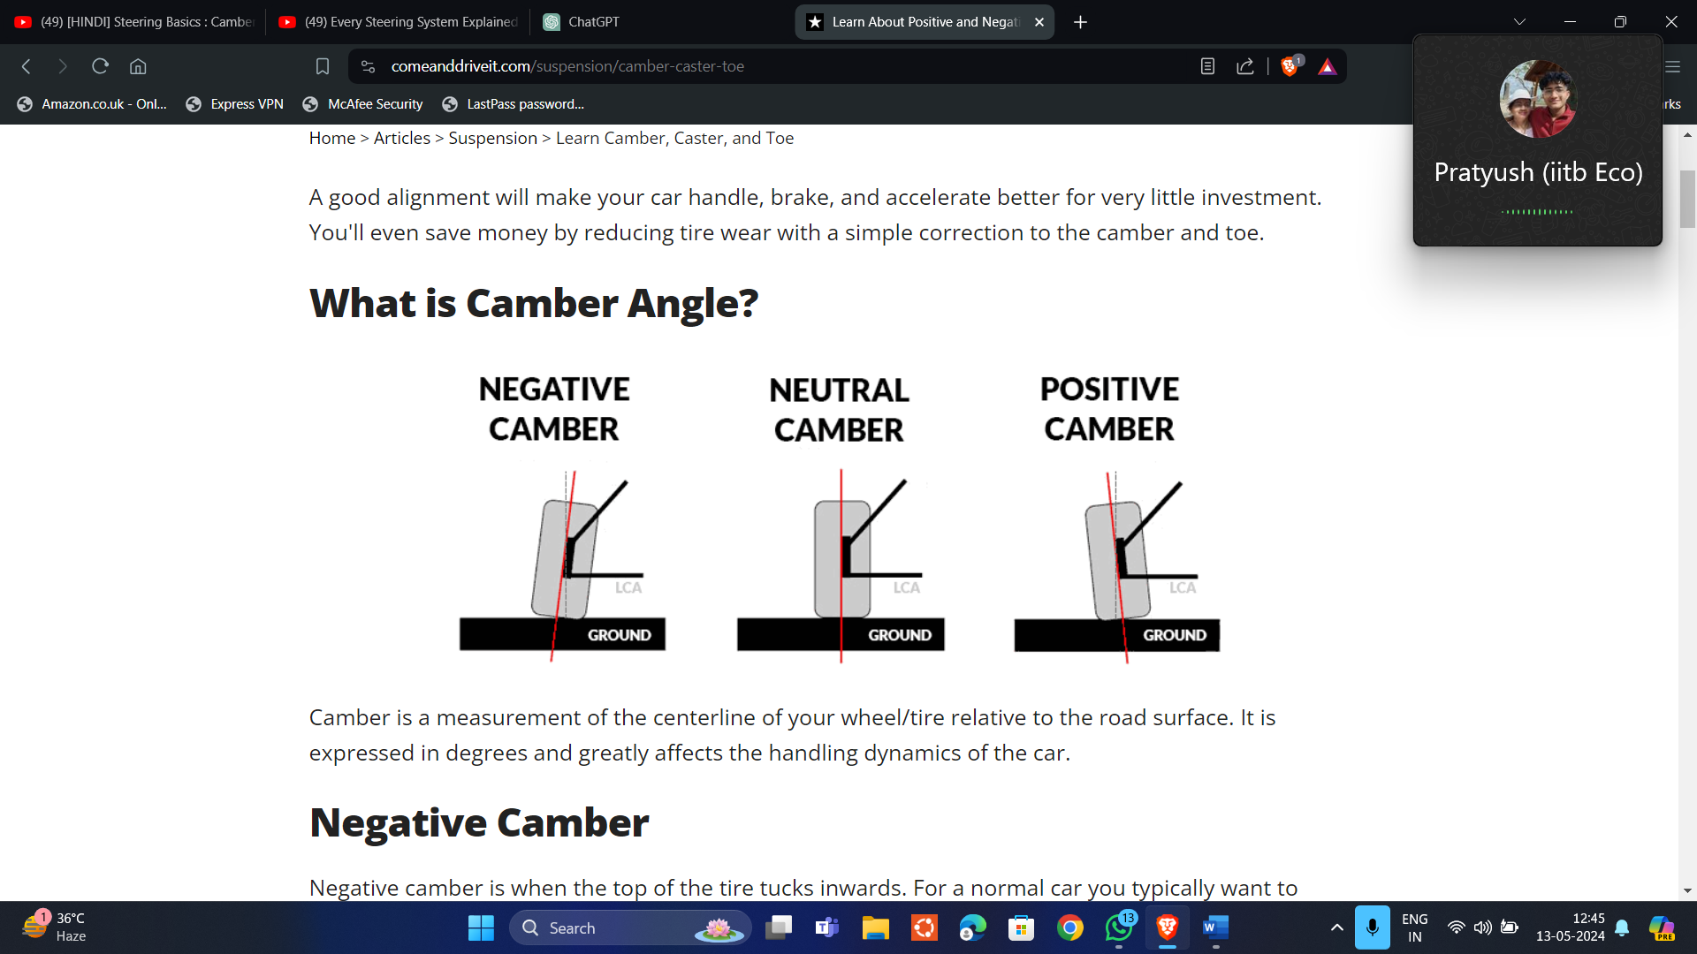

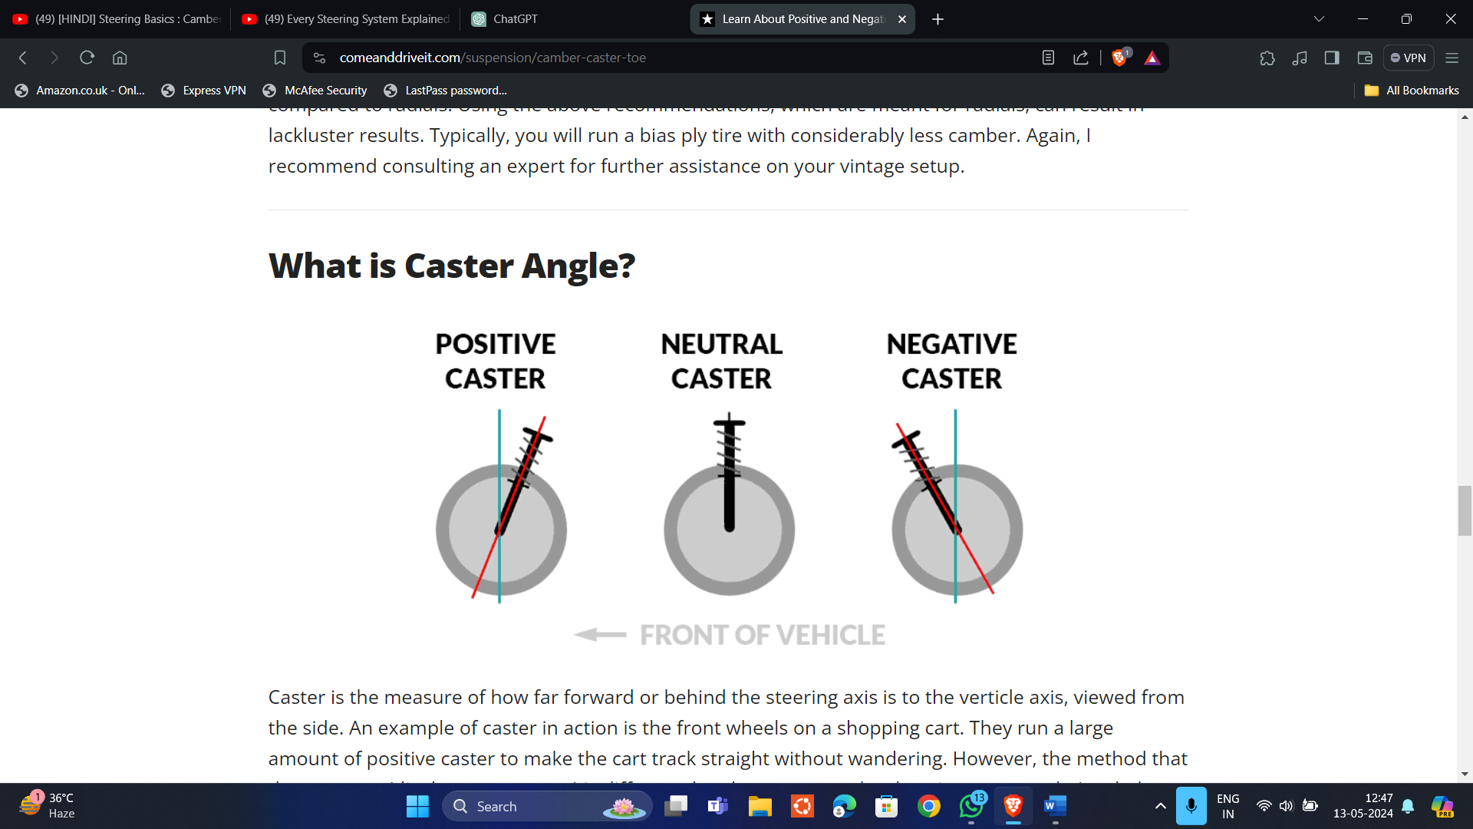

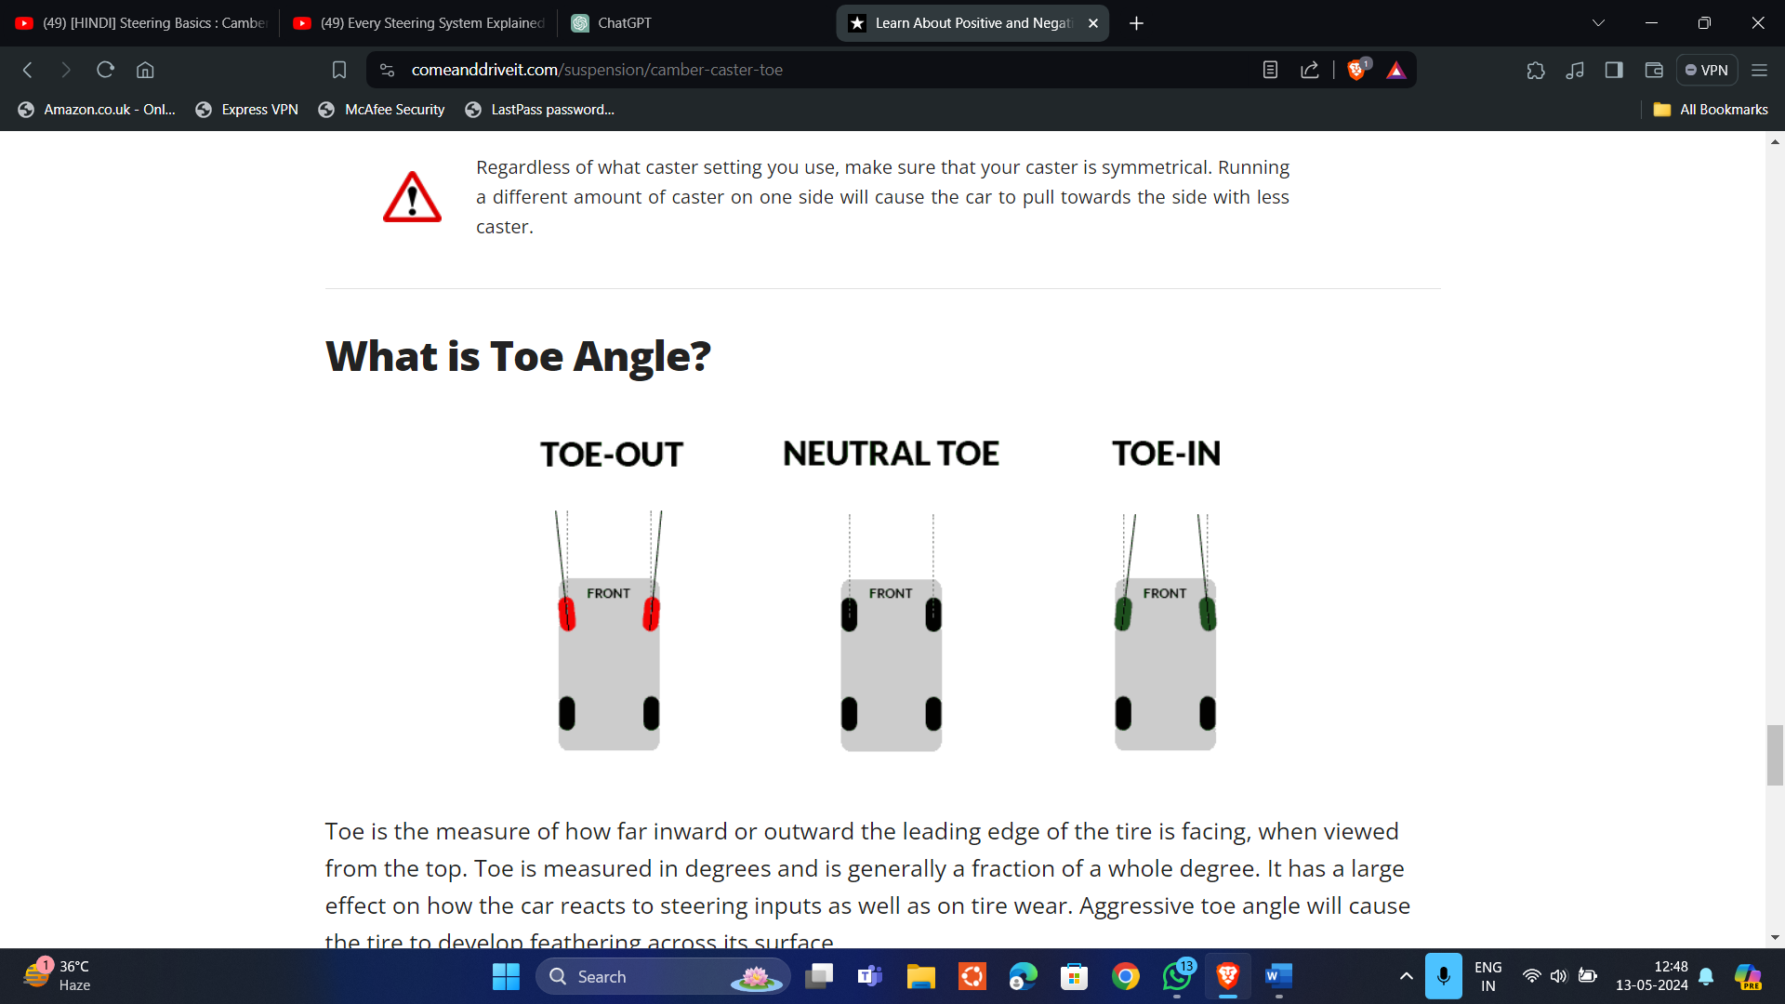

Types of steering mechanisms:

1)Four bar steering:

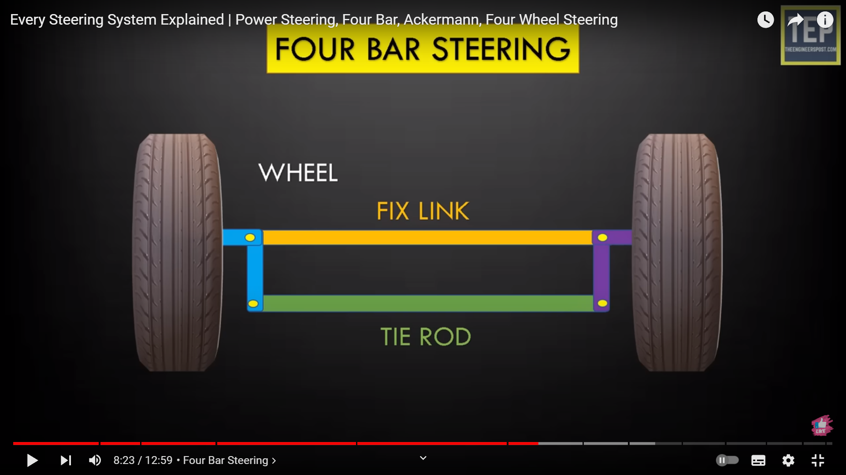

In this mechanism the vehicle turns when the wheels have to turn right the tie rod goes left and vice versa. This mechanism is very simple but effective in turning vehicles; but this mechanism doesn’t follow the pure rolling condition of the wheels. For the pure rolling condition the perpendicular from all four wheels should pass through the center of the circular trajectory in which the vehicle is moving. This mechanism results in slipping between the tyres and the road and thus reduces the durability and health of tyres. For pure rolling the slip angle need to be different as both the wheels have to move in circles of different radius, so the slip angle defined need to be different.

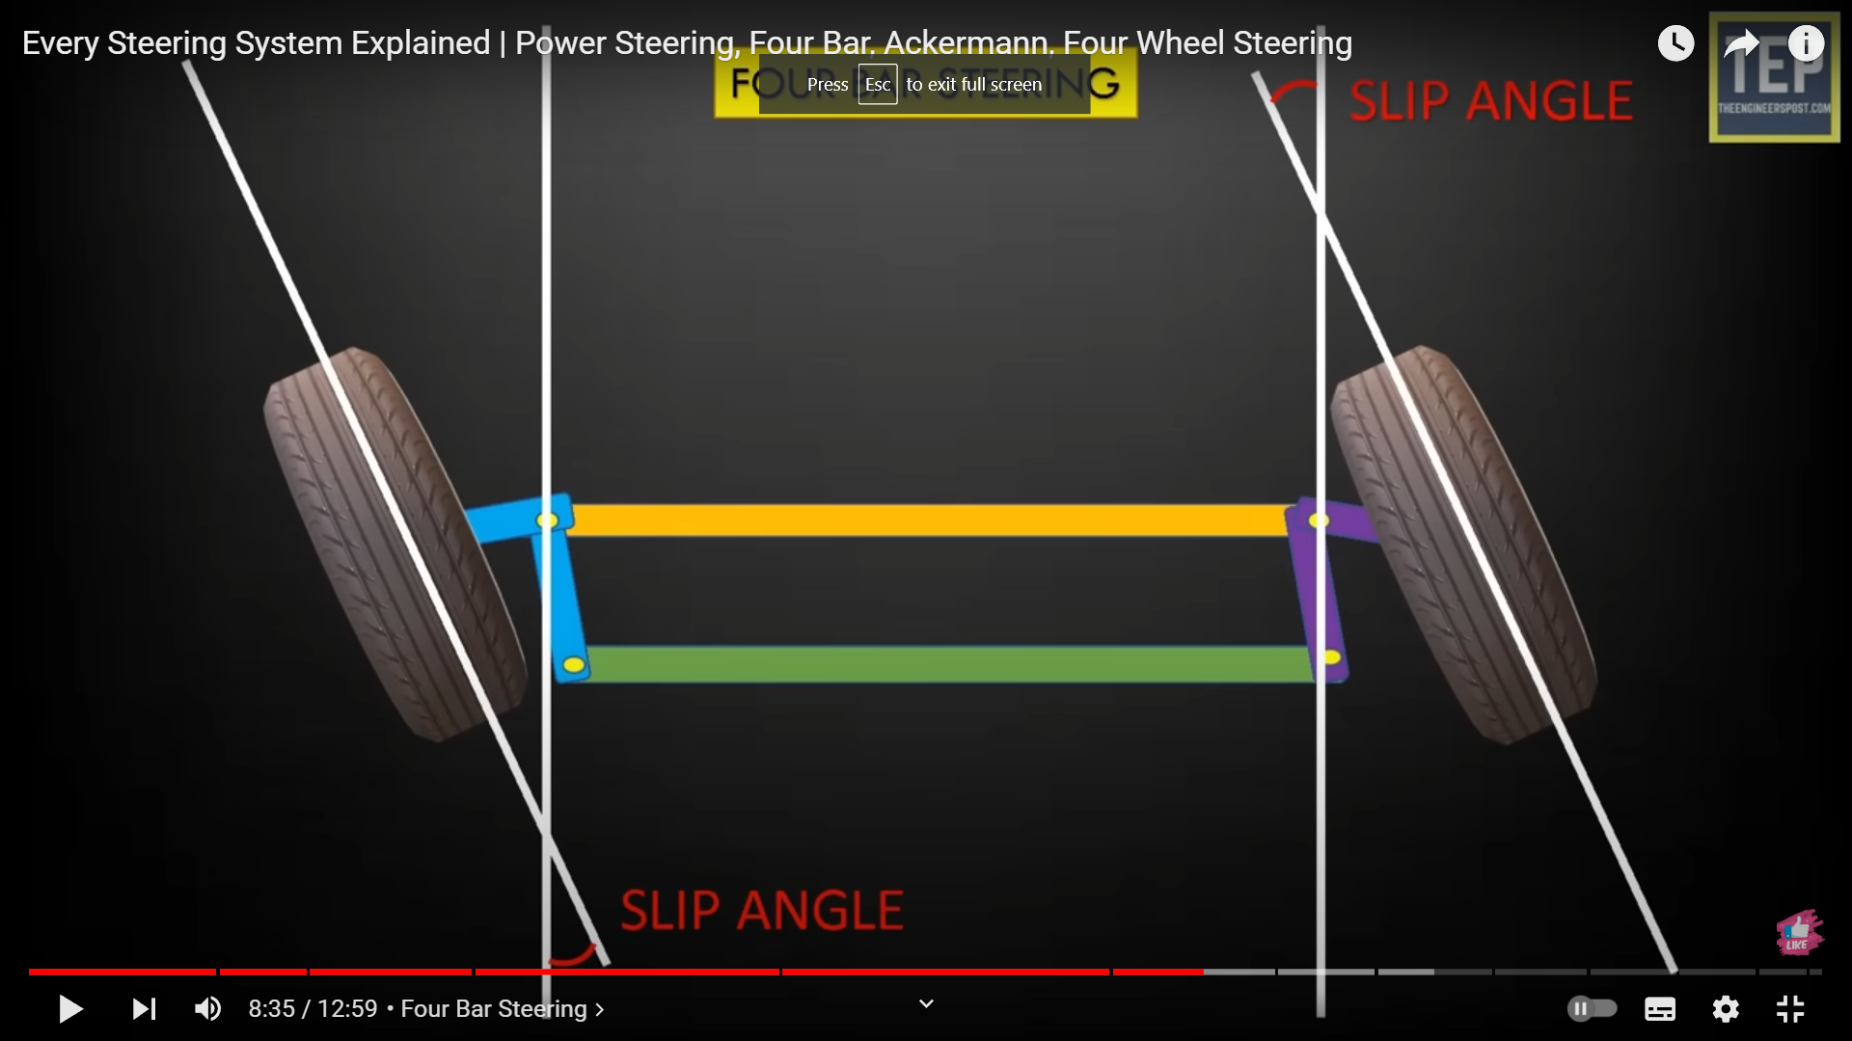

The four-bar steering mechanism provides a simple and effective means of steering a vehicle. It is commonly used in older vehicles and some heavy-duty applications.

2)Ackermann steering:

In Ackermann steering the tie rod length is decreased by using tilted connecting rods. This mechanism removes the corns of four bar steering mechanism.

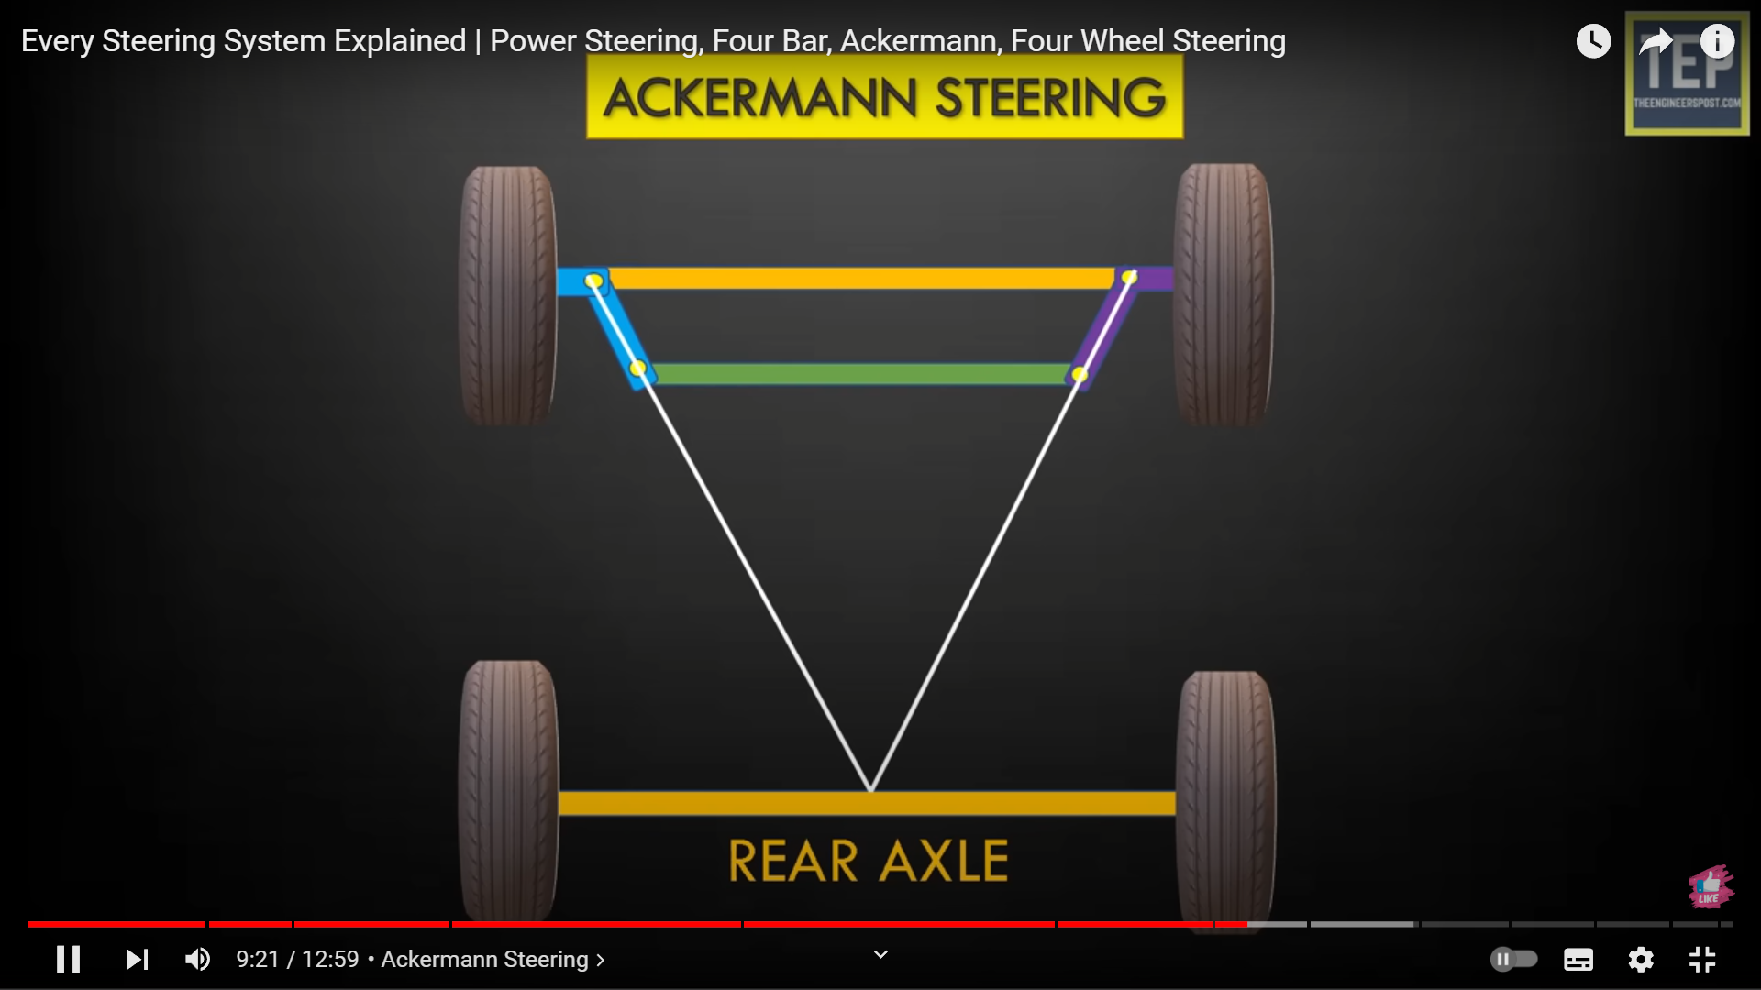

The key principle of the Ackermann steering geometry is that the inside and outside wheels of a vehicle should turn at different angles when negotiating a turn. Specifically, the inside wheel should turn at a sharper angle than the outside wheel. This difference in steering angle compensates for the different paths traveled by the inside and outside wheels during a turn, allowing the vehicle to maintain stability and minimizing tire scrubbing.

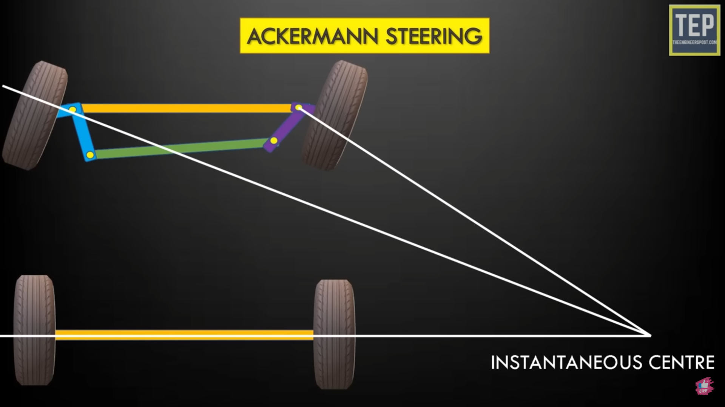

The instantaneous center is the point about which the car rotates with pure rolling condition.

3)Power steering mechanism:

Power steering is a system in vehicles that assists the driver in steering by applying hydraulic or electric power to reduce the effort required to turn the steering wheel. There are two main types of power steering mechanisms:

* Hydraulic Power Steering (HPS): When the driver turns the steering wheel, a hydraulic pump, usually driven by the engine, pressurizes hydraulic fluid. This pressurized fluid is then directed to a hydraulic cylinder mounted on the steering mechanism, which assists in turning the wheels.
* Electric power steering (EPS): When the driver turns the steering wheel, sensors detect the steering input and send signals to an electronic control unit (ECU). EPS systems are more efficient than hydraulic systems because they only provide assistance when needed, reducing the load on the engine and improving fuel efficiency.

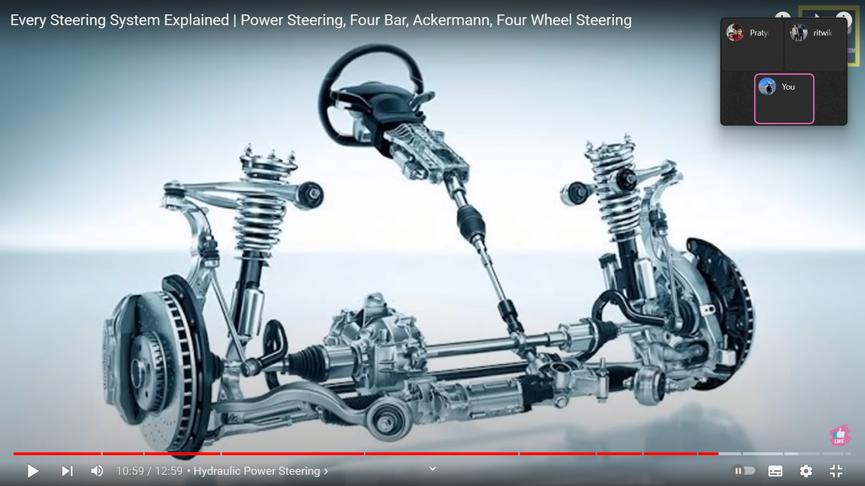

Gears:

Types of gears:

1)Spur Gears: 2) Helical Gears:

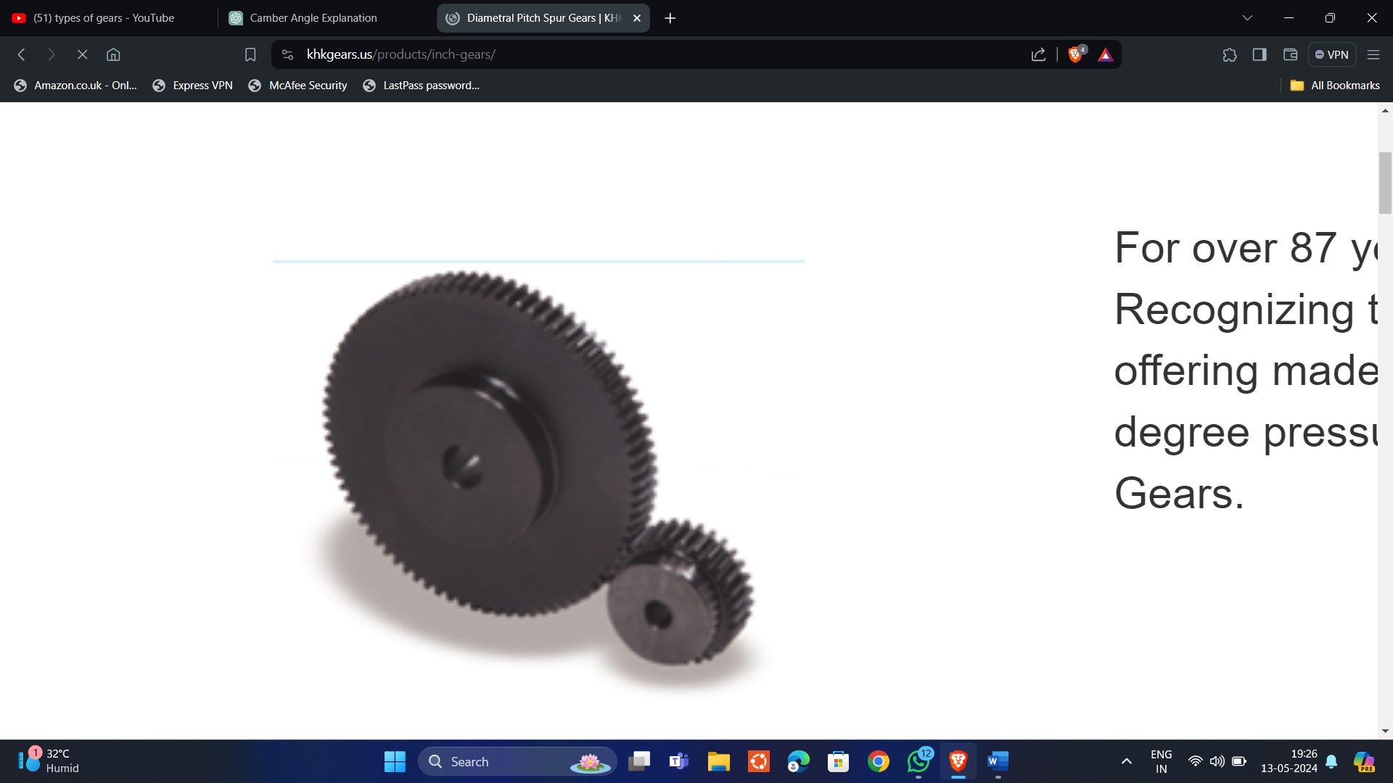 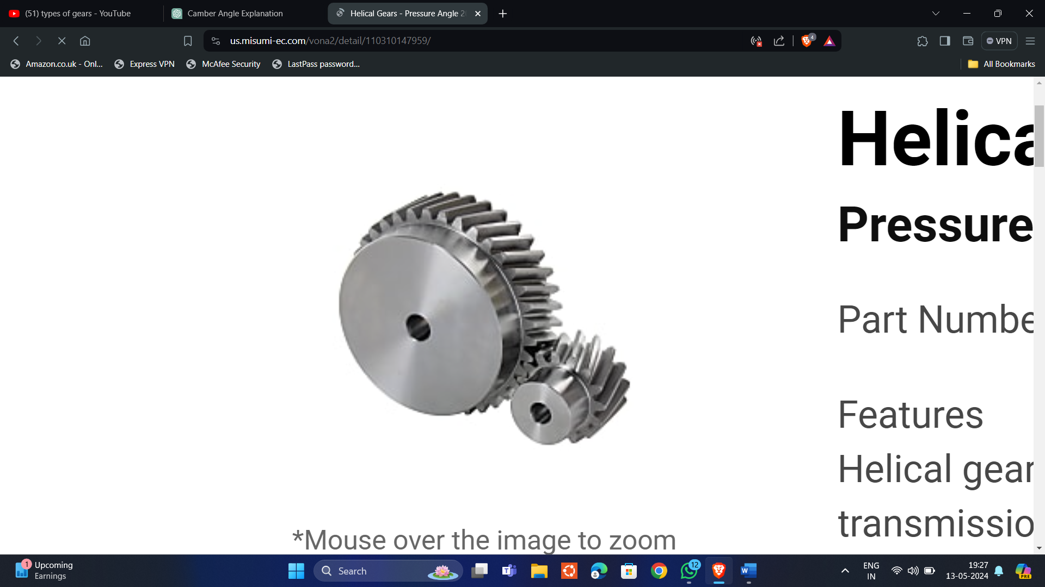

3) Bevel Gears: 4)Worm gears:

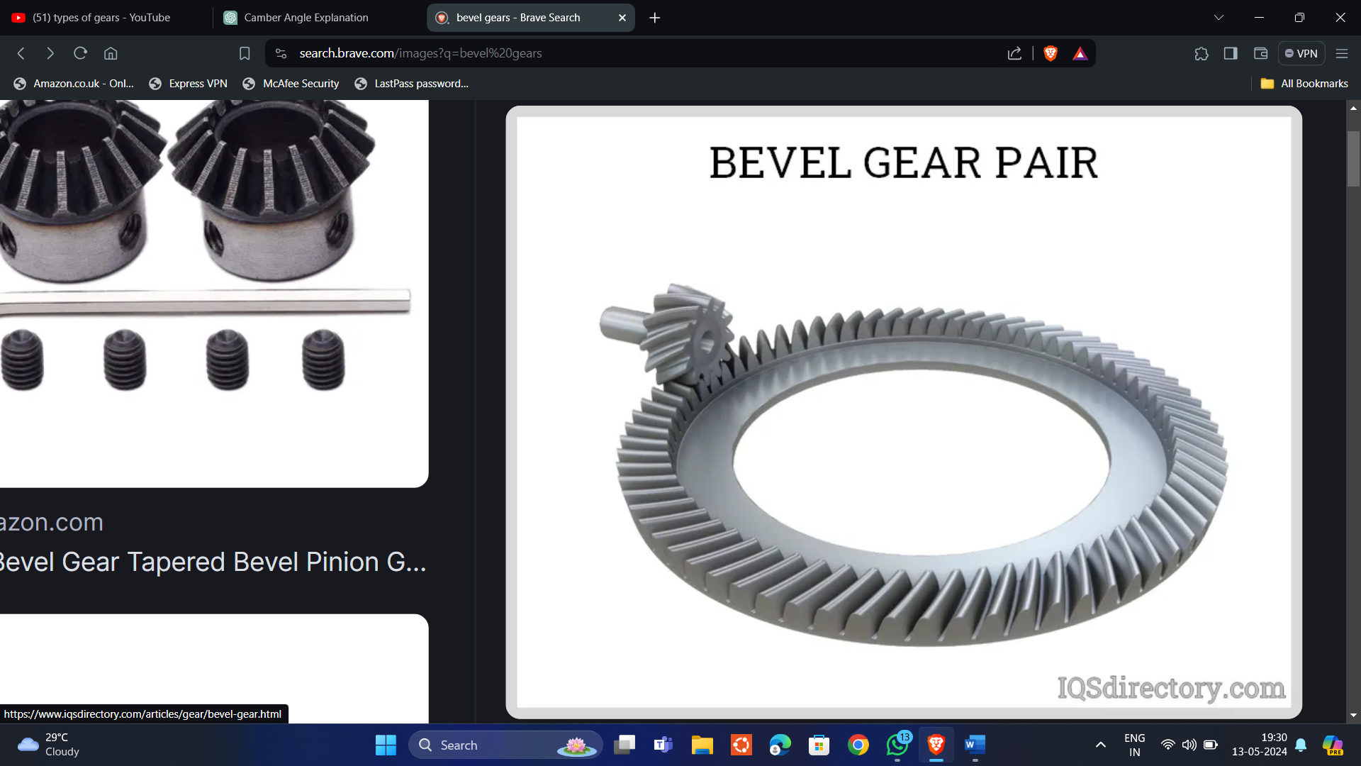 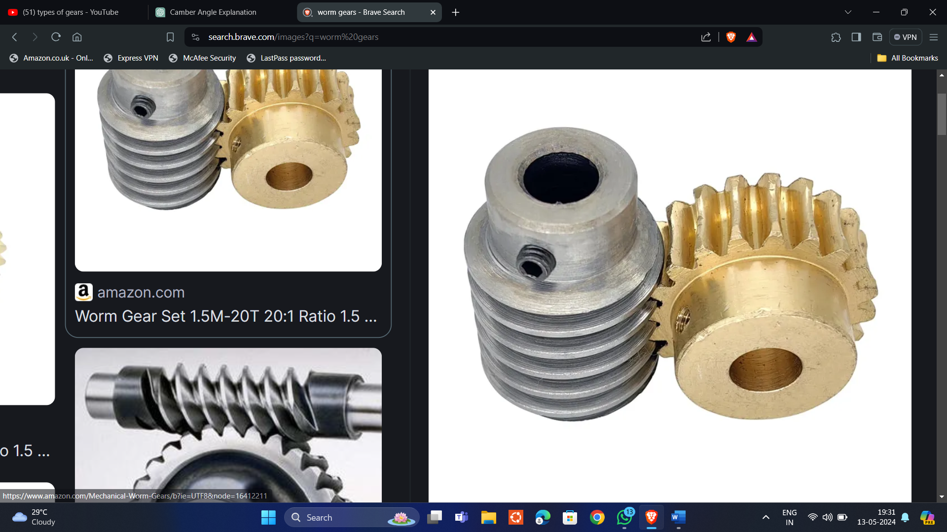

5)Planetary Gears: 6)Rock and Pinion:

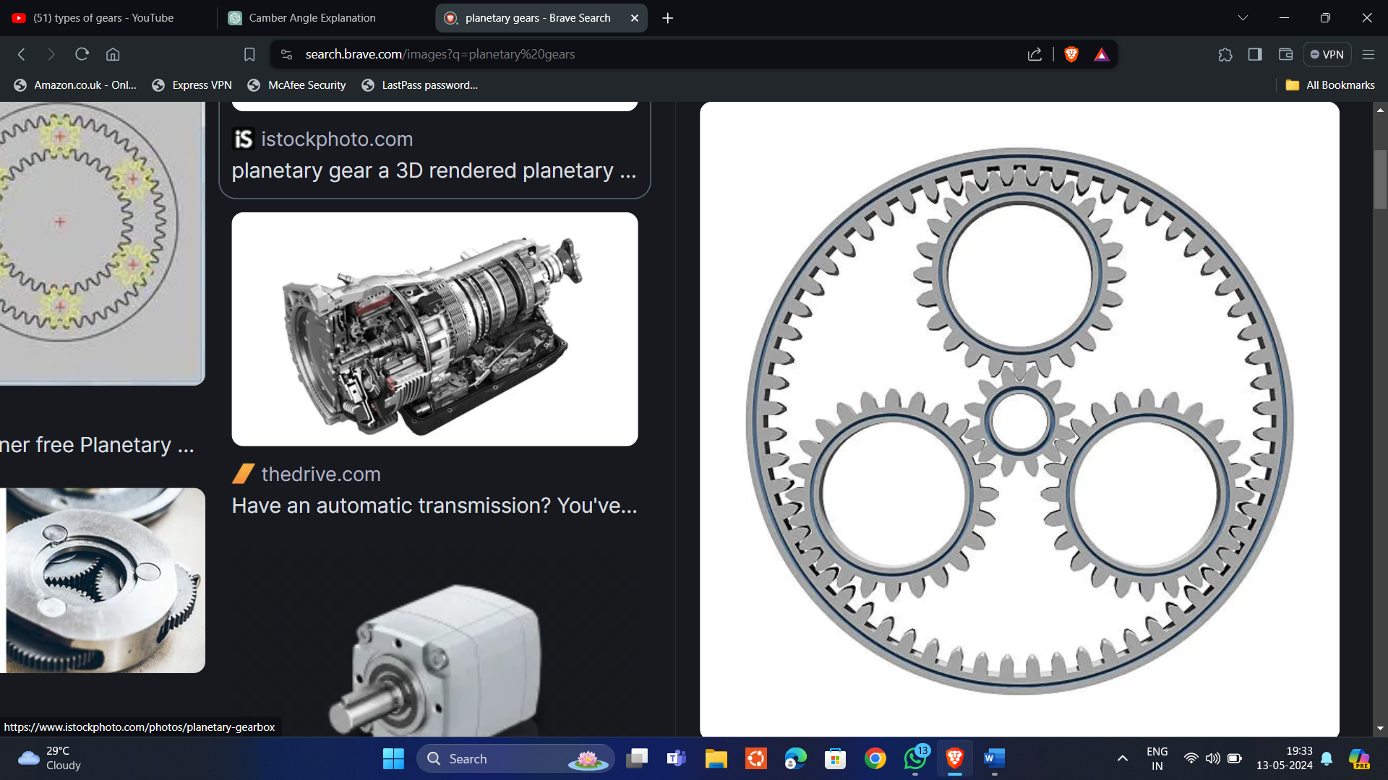 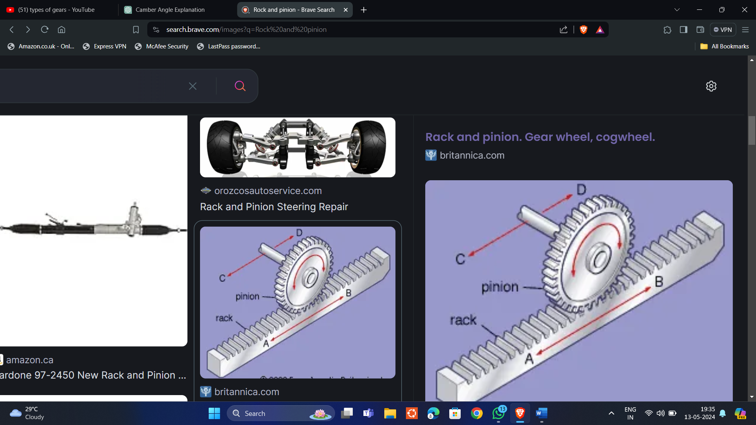

7)Internal Gears:

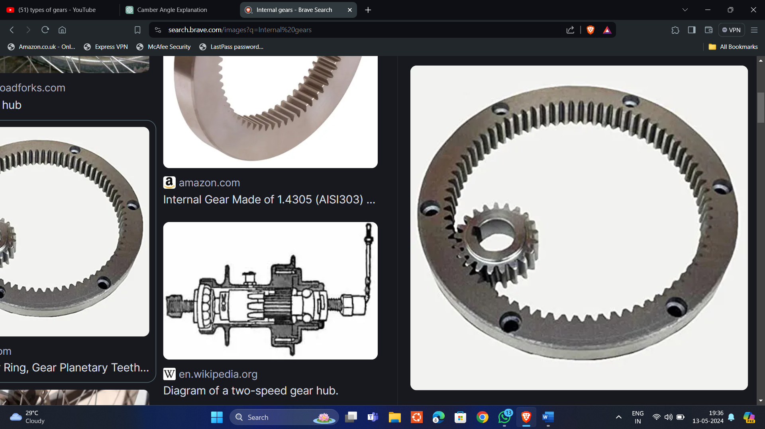

Bearings:

Bearings are mechanical components used to reduce friction between moving parts and support rotational or linear motion. There are various types of bearings, each designed for specific applications and operating conditions.

Types of bearings:

1. Ball Bearings: They consist of balls (usually made of steel or ceramic) housed within two rings (inner and outer race). Ball bearings support radial and axial loads and provide low friction

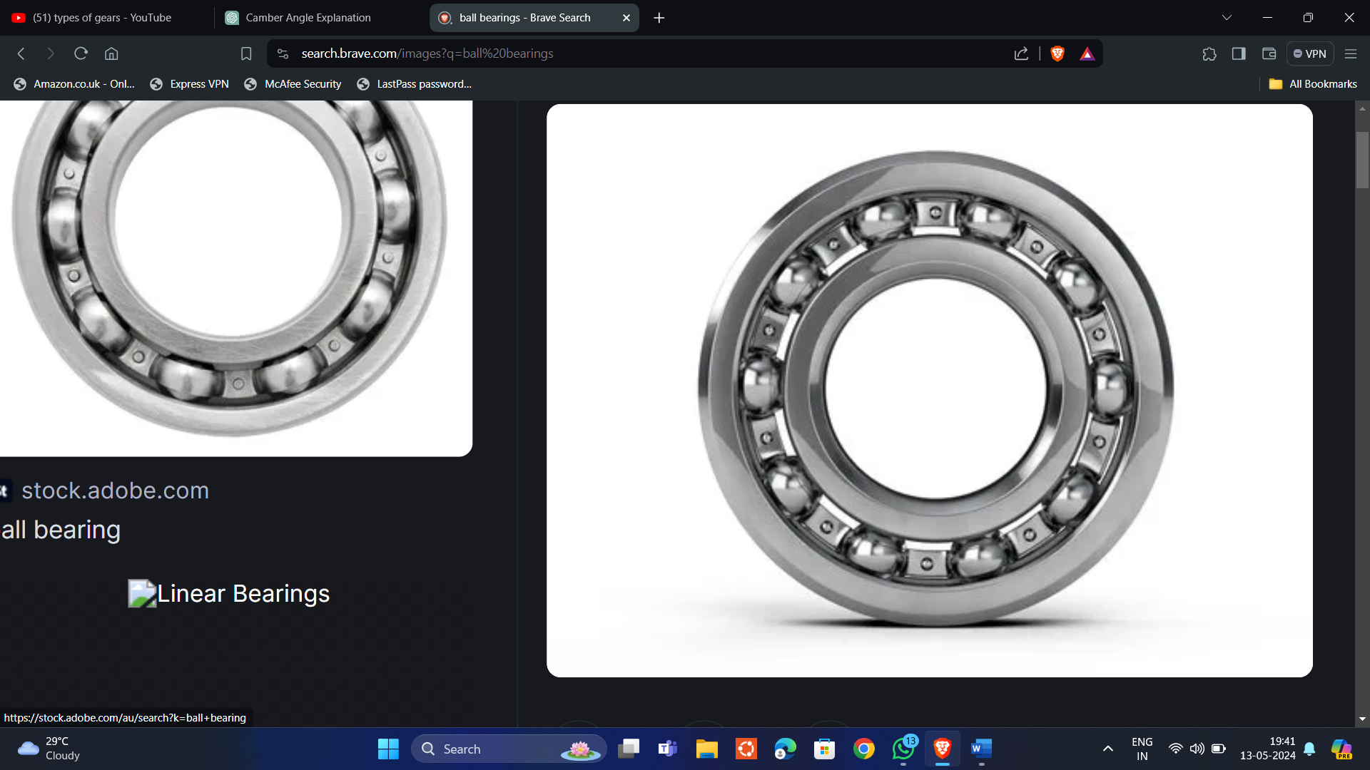

2)Roller Bearings:

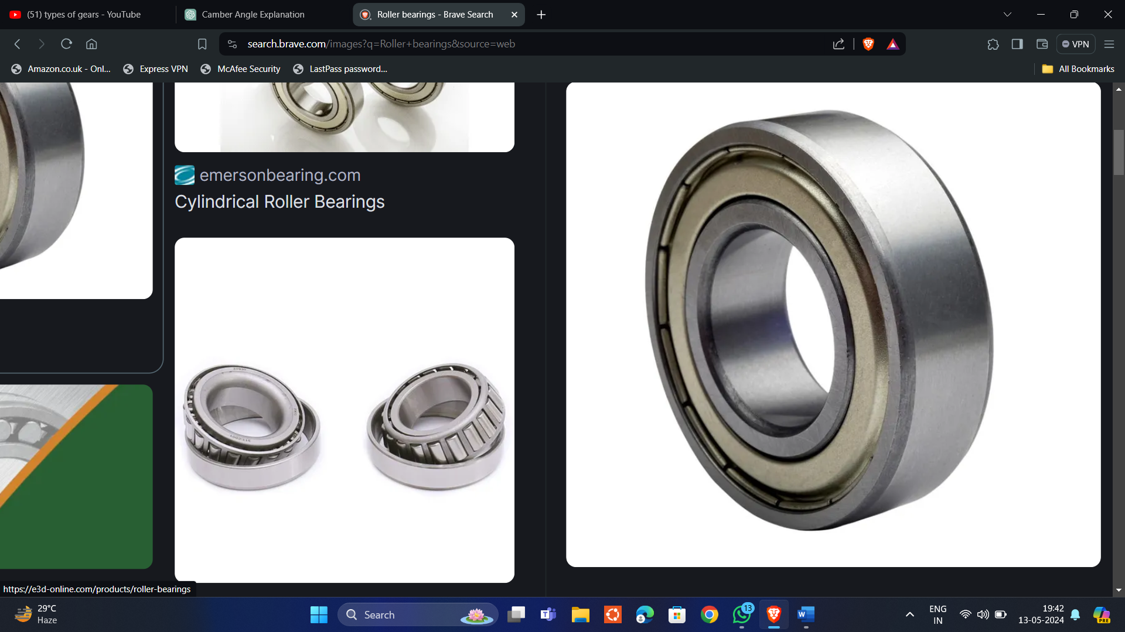

3) Needle Roller Bearings: Needle roller bearings have cylindrical rollers with a high length-to-diameter ratio, allowing them to support high radial loads in a compact design.

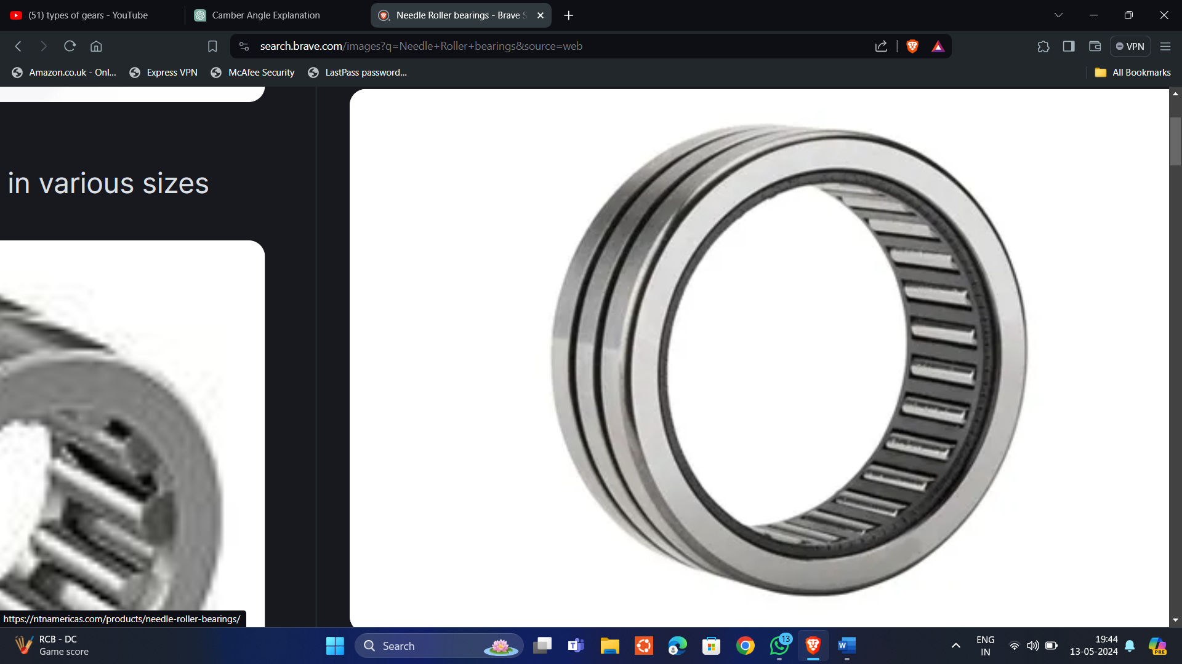

4)Ball thrust bearing: Ball thrust bearings consist of ball bearings arranged in a cage and housing washers to accommodate axial loads in one direction.

